**[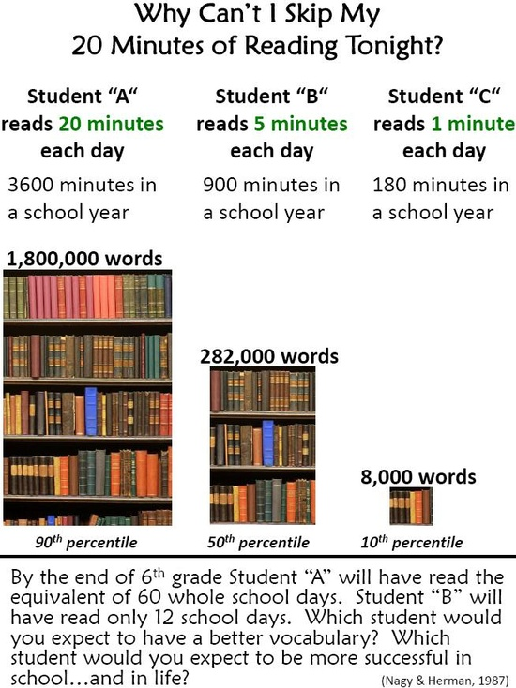](http://edudemic.com/2013/01/skipping-your-reading-homework/)**