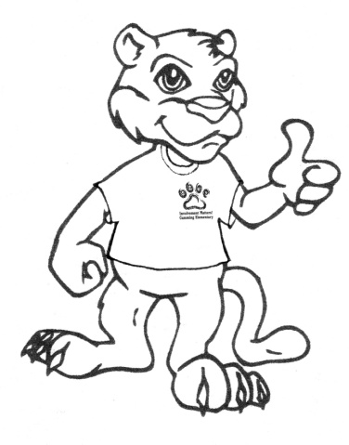

1. You may check out up to **six (6)** items at a time.
2. Please sign out all materials in the check-out binder.
   1. Include student’s name & teacher
   2. Include parent’s name & phone number
3. You may keep the materials for **two (2) weeks**. Please return them two (2) weeks from the check-out date.
   1. Parents may return materials to the yellow bucket during the school day and check out more materials.
   2. Students may return materials to the yellow bucket but may not check out more materials.
4. If you have any questions, please contact Katy Gunter, Parent Involvement Coordinator. Her office is right outside of the media center (in room 531).

You will receive a red token the *first time* you check out from the PRC. We hope you will use these resources all year!

  
If you ever have suggestions of materials for the Parent Resource Center, please let us know! We can use your feedback to guide our purchases using Title I Parent Involvement funds.