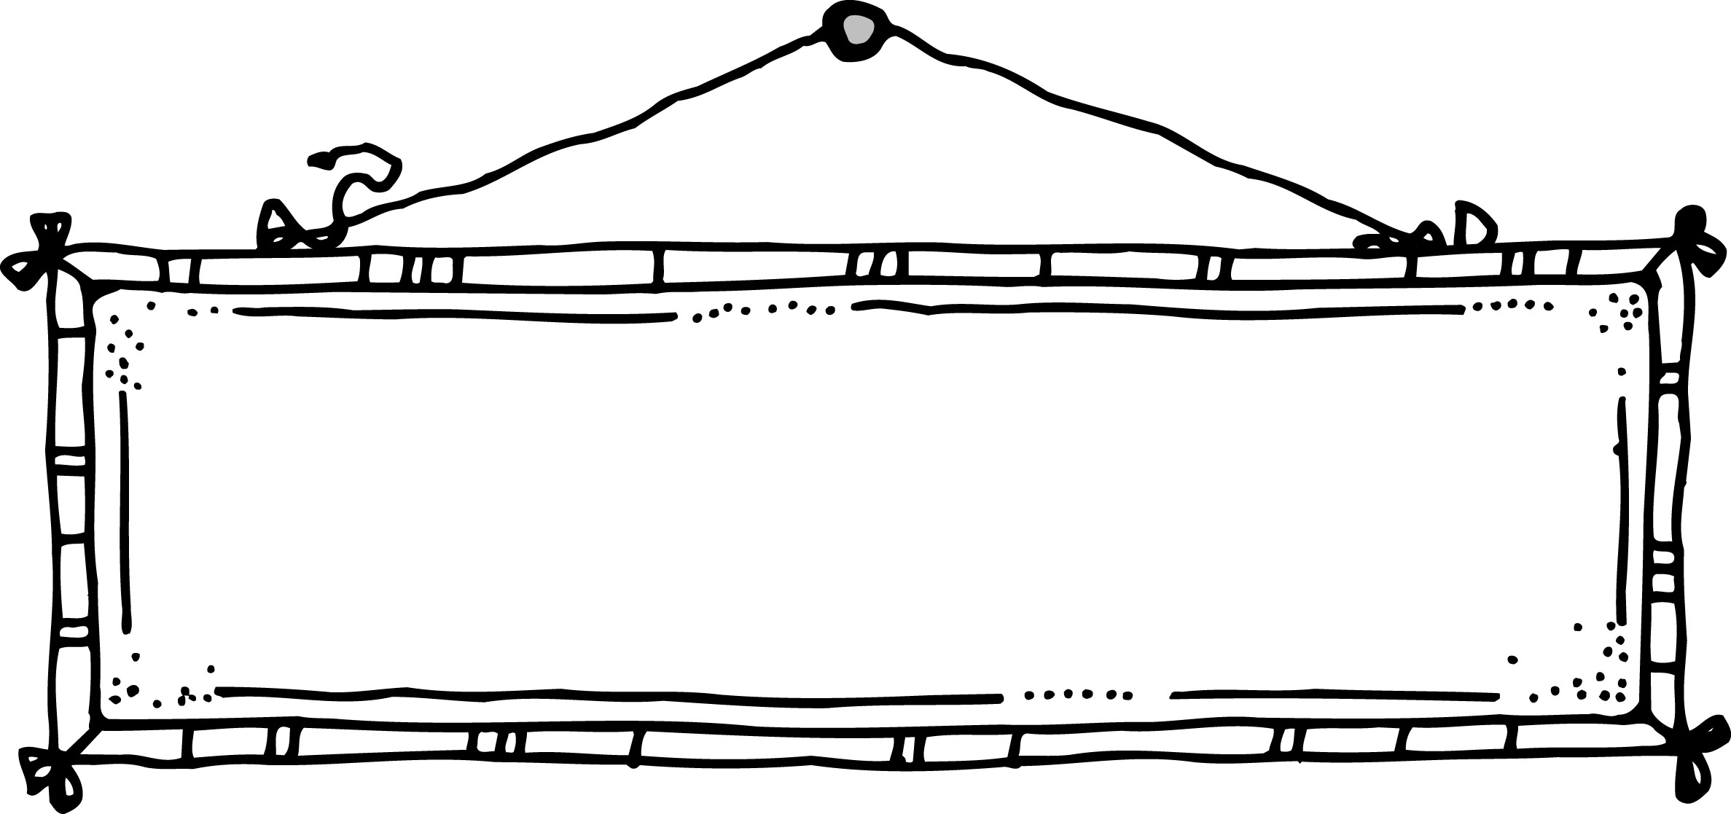
Comprehension Conversation Starters
Non-Fiction

Within | - Explain what you learned about…  - How does ___ work?  - Talk about…  - What is an example of …?  - What causes _____?  - Describe the types of…
Beyond | - Why is/are ___ important?  - How does a ____ change?  - Why did ___ want/do ___?  - Do you think ___ is important? Why?  - How do ___ feel about each other?  - What is a question you still have?  - What is the main idea of this book?
About | - Show the sections in this book. What info. Is in each section? Is this a good way to organize the info.?  - How did the writer help you understand ______?  - Select a passage that helped you know ____.  - Did the writer give a balanced view of ____?  - Explain what the writer meant…  - What does the word ___ mean in this book?  - How did the writer get you interested?  - Look back and find some powerful words/phrases… Explain what they mean.  - How does the writer communicate a feeling of …? Give an example.

Comprehension Conversation Starters
Within | - What was the problem in this story?  How did ______ solve it?  - What were the important points?  - Summarize the main events.
Beyond | - Tell some ways that ____ & ____ are alike/diff.  - How did ____ feel when…? Why?  - How did ____ change? Why?  - How was ___ like ____? (characters)  - How was ___ not like ___? (characters)  - What did ____ learn?  - Why do you think ___ did ____?  - Do you think____? Support your answer.  - From reading, what kind of person do you think ___ is? Why?
About | - Is this a good title? Why or why not?  - What did ____ learn?  - Why do you think the writer said…?  - How did the writer help you know…? Show a place in the story that helped you know that.  - What did ___ mean when he said…?  - What was the most important part of the story?  - What was the writer’s message/ what lesson is he trying to teach?  - How did the writer start/end the story? Why do you think he did that?  - What is the significance/ connection…?
Fiction

